Paper Title Should be Short and Concise (Center, Bold, 16pt)

Roman Peshin^{1,2}, Jonn White³, Ahmed Saeed⁴ (10 pt)
¹Department of Electrical Engineering, Faculty of Engineering, Ural Federal University, Russia (8 pt)
²Department of Computer Science, Moscow State University, Russia
³Department of Power Engineering, Michigan University, USA
⁴Department of Electrical and Information Engineering, College of Engineering, Cairo University, Egypt

Article Info |  | ABSTRACT (10 PT)
Article history:  Received Sep 4, 2025  Revised Oct 24, 2025  Accepted Nov 15, 2025 |  | An abstract typically stands apart from the article, thus it needs to function independently. It should allow readers to grasp the document’s main content, assess its relevance to their interests, and decide if they want to read the full document quickly and accurately. An effective abstract should be clear, self-sufficient, outlining the issue, proposed solutions, and key findings and conclusions. The abstract's length should be between 100 and 200 words. While references are generally discouraged, necessary citations should include the author(s) and year(s). Use standard terminology; avoid uncommon abbreviations, but if used, they must be defined at their first occurrence in the abstract. No citations from other literature are to be included. The keyword list should contain 5 to 7 keywords, which are not in the title, for indexing and abstracting purposes. (9 pt).
Keywords:
First keyword
Second keyword
Third keyword
Fourth keyword
Fifth keyword
This is an open access article under the CC BY-SA license.

Corresponding Author:
Roman Peshin
Department of Electrical Engineering, Faculty of Engineering, Ural Federal University
Taganka 10, Ekaterinburg, Russia
Email: r.peshin@urfu.ru

- INTRODUCTION (10 PT)
The prescribed format for the main text is left-aligned columns on A4 sized paper. The margins are specified as 2.5 cm for both the top and left sides, with 2 cm margins on the right and bottom. Manuscripts need to be composed in Microsoft Word, employing single spacing and Times New Roman font at a 10 pt size. The length of original research articles should not exceed 15 pages, whereas review or survey papers are permitted up to 20 pages.
Titles of articles require brevity and relevance, capped at roughly 10 words. They should eschew acronyms, abbreviations, or detailed methods unless the paper is about a new method. Titles are integral to information retrieval systems, so avoid extended formulas or superfluous phrases such as "Investigations of...", "Analysis of...", etc.
A concise and informative abstract is essential, outlining the purpose, principal results, and major conclusions of the research. Given that abstracts often stand independently, it is advisable to omit references, except when absolutely necessary. Necessary abbreviations should be clarified at their first instance in the abstract. The abstract should be followed by a maximum of 5 keywords, employing American English spellings and focusing on specific rather than broad or plural terms. Abbreviations should be minimal and only include those established in the field.
The precision of titles is vital for indexing and abstracting services to facilitate accurate cross-referencing and searching. Improperly titled papers may not reach their target audience effectively.

The Introduction should provide a thorough background, a clear statement of the problem, a review of pertinent literature, the proposed approach or solution, and emphasize the innovative aspect of the research within 3-6 paragraphs. It should be comprehensible to a diverse scientific readership. Bibliographic citations must adhere to IEEE formatting, and any foreign language terms should be in italics. The manuscript should be structured into sequentially numbered sections with distinct headings: 1. Introduction, 2. Literature Review, 3. Methodology, 4. Results and Discussion, and 5. Conclusion.

- METHODOLOGY (10 PT)
Describing the research chronology entails outlining the research design, procedures (such as algorithms, pseudocode, etc.), testing methods, and data collection processes [4]–[7]. The narrative of the research process should be bolstered by references to ensure its scientific validity [2], [4]. Figures 1-2 and Table 1 should be centered as demonstrated below and referenced appropriately in the text [1], [3]–[5]. The settlement curves observed at SG1 are depicted in Figure 2(a), while those at SG2 are shown in Figure 2(b).

Figure 1. Shows the flowchart of the AI-based models and experimental methods applied
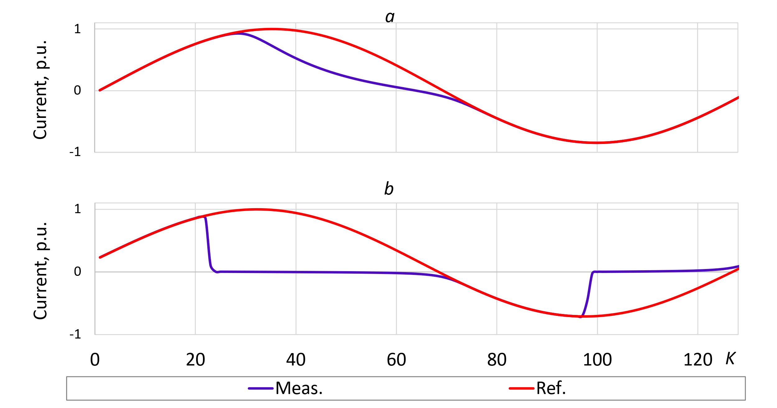
(a)

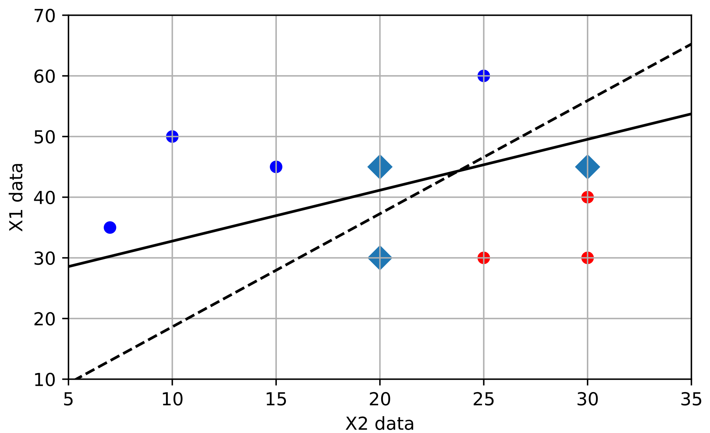
(b)

Figure 2. The relationship between X1 and X2 variables.

Table 1. Speed and power of variables
Variable | Speed (rpm) | Power (kW)
x | 10 | 8.6
y | 15 | 12.4
z | 20 | 15.3

- RESULTS AND DISCUSSION (10 PT)
This section presents the research results and provides an extensive discussion. The results are displayed through figures, graphs, tables, and other formats for easy comprehension by the reader. The discussion may be organized into multiple sub-sections for clarity.

3.1. Sub section 1
Equations must be centered on the line and sequentially numbered, with the equation numbers in parentheses aligned to the right margin, as shown in (1). It is recommended to use Microsoft Equation Editor or MathType for formatting equations.

$E_{v}-E=\frac{h}{2.m} (k_{x}^{2}+k_{y}^{2}$) (1)

All symbols that have been used in the equations should be defined in the following text.

3.2. Sub section 2
Appropriate referencing of other works is essential to prevent plagiarism. When citing a reference, use the reference number like [1], or [2] for citing multiple references. The References section includes examples of different types of reference items. Each entry in the references section should be in 8 pt font size [1]–[6].

3.2.1. Subsub section 1
yy
3.2.2. Subsub section 2
zz

- CONCLUSION (10 PT)
Ensure that the expectations set in the "INTRODUCTION" section align with the outcomes presented in the "RESULTS AND DISCUSSION" section, thereby ensuring consistency. Additionally, consider discussing the potential for future research developments and the applicability of the study's findings in subsequent investigations, as informed by the results and discussions.

ACKNOWLEDGEMENTS (10 PT)
Author thanks and acknowledgements.

REFERENCES (10 PT)
The main references are international journals and proceedings. All references should be to the most pertinent, up-to-date sources and the minimum of references are 20 entries (for original research paper) and 50 entries (for review/survey paper). References must be written in APA style. Please use a consistent format for references-see examples (Times New Roman 8 pt):

REFERENCES
[1] Senyuk, M., Safaraliev, M., Kamalov, F., & Sulieman, H. (2023). Power System Transient Stability Assessment Based on Machine Learning Algorithms and Grid Topology. Mathematics, 11(3), 525. https://doi.org/10.3390/math11030525
[2] Safaraliev, M., Kiryanova, N., Matrenin, P., Dmitriev, S., Kokin, S., & Kamalov, F. (2022). Medium-term forecasting of power generation by hydropower plants in isolated power systems under climate change. Energy Reports, 8, 765-774. ttps://doi.org/10.1016/j.egyr.2022.09.164
[3] Pazderin, A., Zicmane, I., Senyuk, M., Gubin, P., Polyakov, I., Mukhlynin, N., ... & Kamalov, F. (2023). Directions of Application of Phasor Measurement Units for Control and Monitoring of Modern Power Systems: A State-of-the-Art Review. Energies, 16(17), 6203. https://doi.org/10.3390/en16176203
[4] Liu, Y., & Feng, C. (2023). Promoting renewable energy through national energy legislation. Energy Economics, 118, 106504. https://doi.org/10.1016/j.eneco.2023.106504
[5] Guan, Y., Yan, J., Shan, Y., Zhou, Y., Hang, Y., Li, R., ... & Hubacek, K. (2023). Burden of the global energy price crisis on households. Nature Energy, 8(3), 304-316. https://doi.org/10.1038/s41560-023-01209-8
[6] Andreas, A., Mavromoustakis, C. X., Mastorakis, G., Batalla, J. M., & Pallis, E. (2022, May). Energy Conservation by using the Integration of Distributed Energy System in Smart Vehicles. In 2022 IEEE 7th International Energy Conference (ENERGYCON) (pp. 1-6). IEEE. https://doi.org/10.1109/ENERGYCON53164.2022.9830427

